Project Charter
Project Name
Agile Dashboard Implementation Project
h
12 Nov 2025
Project Documentation
12 Nov 2025
Sprint 2: Dashboard Creation
11 Nov 2025
11 Nov 2025
Project Charter Preparation

Sprint 1: Data Cleaning
Project Manager
Using free tools (Excel, Power BI, Trello)
Scope kept minimal and focused
Risks and Constraints
Target Date
Milestone
Data inconsistencies
Manual cleaning and validation
Limited resources
Limited time (1-day project)
Mitigation Plan
Risk / Constraint
Project Manager / Analyst
Vishal Menaria
Roles
Name
Milestones
Total Members
Power BI dashboard showing key sales KPIs.
Agile-based execution using sprints and backlog.
Documentation of SDLC phases and progress.
Improved skills in project planning and reporting.

This project aims to apply Agile and SDLC principles to manage the development of a Power BI dashboard for visualizing key sales KPIs. It simulates a real-world analytics project where structured planning, sprint-based execution, and data visualization improve project efficiency and reporting. The project enhances understanding of project workflows, task management, and data-driven decision-making — essential skills for project management roles.
Expected Goals / Deliverables
Expected Goals / Deliverables
Date Approved
Signature
Self (Individual Simulation Project)
11-November-2025
Vishal Menaria
Project Sponsor
Project Description
Design and implement a Power BI dashboard to visualize key sales and profit KPIs using Agile and SDLC principles. Tasks are managed through sprints and a backlog, simulating real-world project execution and delivery. The outcome is a dashboard and documentation demonstrating data-driven project planning and reporting

Sprint Backlog
Task | Sprint | Priority | Status | Remarks
Collect sales dataset from Kaggle | Sprint 1 | High | Done | Used Superstore Sales Data
Clean and format data | Sprint 1 | High | Done | Removed duplicates, renamed columns
Create calculated column (Profit Margin %) | Sprint 1 | Medium | Done | Added new field
Build visuals (Sales by Region, Monthly Trend) | Sprint 2 | High | In Progress | Power BI visuals
Add filters and slicers | Sprint 2 | Medium | To Do | Filter by region & month
Finalize layout and colors | Sprint 2 | Medium | To Do | Dashboard polish
Prepare short project summary | Sprint 2 | Medium | To Do | Documentation

Note: Sprint 1 = Day 1” and “Sprint 2 = Day 2” as headers or notes

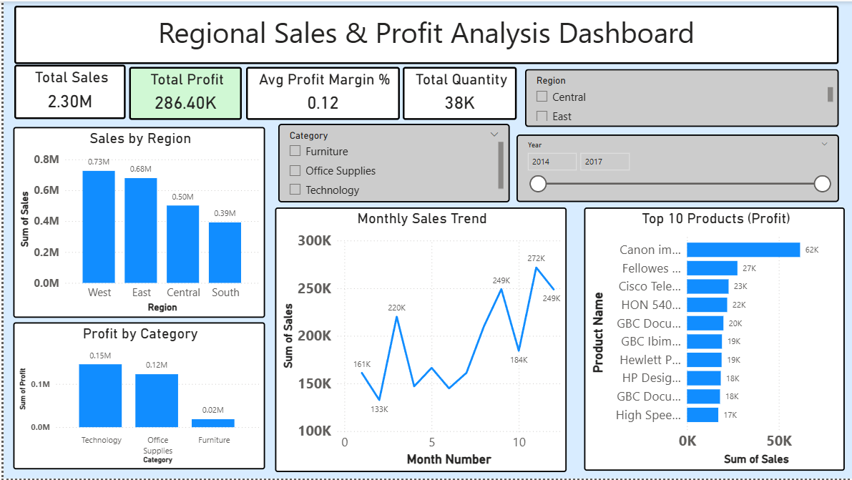
Figure 1: Final Power BI Dashboard showing regional sales KPIs.

